100 AI Interview Questions and Answers



**Anish Mahapatra**

Contents

List of Figures 7

Introduction 8

Q. What is the Gartner Hype Cycle? 8

Structure of the blog 9

**Part A: Topic-Based Questions** 9

1 AutoML 10

Q. What is Auto ML and how does it work? 10

Q. What are some ways to implement AutoML? 10

Q. What is transfer learning and how does it compare to a neural architecture approach? 10

Q. What is GitHub’s copilot? Is it an implementation of AutoML – explain! 10

Q. How does AutoML work? 11

2 MLOps 11

Q. What is MLOps and how does it work? 11

Q. Explain how the MLOps lifecycle can be applied 12

Q. What is the difference between MLOps and DevOps? 12

Q. What are the components of MLOps? 12

3 AI Cloud Service 13

Q. What is an API? How do we deploy our own API to productionalize a ML Model? 13

Q. What are the popular Cloud Services that support AI implementations? Explain! 13

Q. What Cloud Service would you prefer? Why? 13

Q. What are some scenarios where AI Cloud Service could be used to increase ROI? 13

Q. What are the benefits of Machine Learning on the cloud? 13

4 NLP: Natural Language Processing 13

Q. What is NLP? Explain some use-cases of NLP? 13

Q. What are chatbots? What are the various implementations of chatbots used? 13

Q. What are the main issues faced by companies when implementing chatbots? 13

Q. Explain some NLP use-cases. 13

Q. How does Transfer Learning aid in building better and faster NLP models? What are the top three most popular implementations of pretrained language models? 14

5 AI Governance & Scalable AI 14

Q. Now that large companies are leveraging AI to make decisions that affect human beings everyday, it is important to critique the algorithms implemented. On that note, what is AI governance? 14

Q. What are the components of AI Governance? 14

Q. Good AI exists. Looking at the top companies in the world, we know that a robust framework exists where AI can scale. How do the best compnies in the world build Scalable AI? 14

Q. What are the difficultes when it comes to scaling implementations of AI? 14

Q. State out the Enterprise AI Journey. 15

6 XAI / Explainable AI 16

Q. What are some of the common problems faced by companies when it comes to interpreting AI / ML? 16

Q. Explain the concept of XAI and how it can be used in real world implementations? 16

Q. If we were to consider AI/ML Models as black boxes that give us the desired output, what are some of the ways to help being trust back to the models being leveraged? 16

Q. Explain some examples of tools and technologies that can help implement interpretable machine learning or XAI. 16

Q. All of the conversations about XAI seem to be problems of the future. If you were to design a ai / ml model for a business now and productionalize a model, what are some of the considerations you would have as a lead of the project? 16

7 Ethical AI / Federated Learning 16

Q. With a world being driven more towards a privacy-focus mentality, what are some of the recommended approaches companies / teams can take to ? 16

Q. A common statement is “With the onset of the Digital Era”. In the coming years, as AI startes to take over more and more components of human life, the statement is going to transition to “With the onset of the AI era”. Is Ethical AI a real concern or just hype? What are the ramifications? 16

Q. How can Ethical AI be implemented at an enterprise level? What are its implications for Enterprise AI use-cases and Governance? 16

Q. With privacy focus coming to the forefront, a lot of attention has been brought on data collected. A new branch of data collection and processing for ai / ml is federated learning. Explain further. 17

Q. Explain how a model can be monitored after it is moved to production. Break down the approach. 17

8 Cyber Security AI 17

Q. Cybersercurity is the need of the hour. What is a good way to classify all security-related tasks using the PPDR framework? 17

Q. How can machine learning be used within the space of Cyber Security. Broadly explain the various elements of Cyber Security. 17

Q. Mention ten use-cases as to how AI / ML can be used within Cyber Security use-cases. 18

Q. Explain the flow of Cyber Security attacks and how AI / ML models can hel plug the gaps. 18

Q. How can Cyber Security be implemented across a PoC Team or at an enterprise-level with the help of AI / ML? 18

9 RPA: Robotic Process Automation 18

Q. What is Robotic Process Automation? Explain in brief with a few examples. 18

Q. What is the difference between AI and RPA? 18

Q. Explain the landscape of how RPA and AI can be used in tandem to increase revenue at an enterprise-level? Discuss a few use cases. 18

Q. What are the phases of RPA at an Enterprise Level? 18

10 GANs: Generative Adversarial Networks 18

Q. What are GANs? 18

Q. Provide an overall system view of GANs. 19

Q. Explain some uses-cases on the variations of GANs. 19

Q. Name some popular tools used for GANs. 19

**Part-B: Scenario-Based Questions** 19

1Q. How can NLP be leveraged to tackle Fake News and Cyber Bullying? 19

Q. How would you build a governance model for AI in Healthcare. Give examples. 19

Q. Gartner’s report says that 87% of ML Models do not make it to production. What are some of the gaps in the real world when it comes to productionalizing ML Models? 19

Q. A lot of Data Science is being done in Jupyter Notebook. What are some of the ways to productionalize a Jupyter Notebook? 19

5Q. Name some common test frameworks that can be used in AI / ML models? 19

Q. Data Science is said to be primarily a combination of Math, Business and Technology. With automation of various systems in various fields, what does the future of Data Science look like? 19

Q. If you were to pick out top 10 best and worst performing products from across multiple warehouses across India, what would the approach be? 19

Q. Data Science is experimental in nature. Does logging play a part in Data Science? If so, please explain how. 19

Q. What is the difference between a client-serice and an in-house model in Data Science? What are some of the benefits and drawbacks of both? 20

10Q. How you would design scalable architecture to accommodate varying data needs of an organization? 20

Q. What is streaming data? How are architectures designed to handle real-time data? 20

Q. Apple recently came up with a host of measures to advocate for privacy. How can machine learning scale at an organizational level keeping in mind privacy? 20

Q. What is FaaS? What is the imapact of FaaS in the Data Science industry? 20

Q. Exploratory Data Analysis (EDA) is an activity that has traditionally taken a lot of time. Is there any way to streamline and speed up EDA? 20

15Q. Let’s take a general use-case of an an internet product that is run using ads. Name some of the key metrics that can be used to measure performance? 20

Q. Let’s say that we are running ads on Facebook and Instagram to advertise our product. What are some of the ways to assess if engagement has been per expectations for the last month / quarter? 20

Q. Let’s say that we are Netflix and you are given a budget. How would you determine which Original Series we should put our money on? 21

Q. Let’s say are serving a Fortune 500 company and we have the option of unlimited data. Is more data always better? 21

20Q. Let’s say you have a dataset with a million rows and 200+ columns. How can we determine what the most important features in the model are? 21

Q. Why do a lot of Kaggle Competition winners use Ensemble Learning? What is the main idea behind it? 21

Q. Let’s say that we are Uber. How can you use just the GPS data from the car to determine the quality fo the driver? 21

Q. Developers and product managers have hundreds of ideas on a daily basis. For the ideas that are selected to be tested, what is an efficient way to test these hypothesis in the real world? 22

Q. A lot of Data Science projects start our as PoCs. List out what are the things to keep in mind while building a PoC. 22

25Q. What is a MVP? In a field as experimental as Data Science where experimentation is a part of the daily job description, what are some of the ways to maintain client confidence? 22

Q. How to build out a Data Science product from scratch? 22

Q. Let’s say you join a new team and are given data with no context. What would be your approach to prepare for analysis? 22

Q. You are given a classification problem on a fairly complix dataset. From your previous experience, you guesstimate that it will take ~3 months to processs the entire data with business context. How can you maintain client confidence intermittently? 22

Q. A popular algorithm used for classification is Naïve Bayes. Why is it considered “Naïve”? 22

30Q. Let’s say you are given a large dataset of all customers of a telecom company with over 2 million rows and 2000 columns. You have to build a classification model to decide if a customer is likely to churn or not next month. You are given a laptop with limited RAM and no access to cloud resources. What are some of the ways you can go about this? 22

Q. You are very lucky and have got the opportunity to work for an interesting project that is deep in Data Science. The project deals with 5 VP-level stakeholders, all located across various timezones. You realize that every single person has different ambitions and expectations from this high-level project. What are some of the ways you could tackle such a situation? 22

Q. Let’s say you are dealing with customer churn data and you made a classification model with an accuracy of 97%! Why is this a bad measure? Explain your thought process. 23

Q. Projects in the past that used waterfall models used to give a lot of importance to documentation. However, projects that use Agile methodology do not give much importance to documentation. Do you agree with this assupmtion from the perspective of Data Science? 23

1 Real World AI 23

2 Mainstream Computer Vision 23

3 Federated Learning 23

4 Enterprise-Grade AI Solutions 23

5 Future of AI 23

# List of Figures

Figure 1: Data Science is a subset of Artificial intelligence 5

# Introduction

With so many pseudo-data scientists cropping up due to numerous courses that offer theoretical learning, the questions in interviews is getting streamlined to filter those that understand how real-world implementation works. It is important to understand how data flows in the real world and what sort of questions are being discussed across companies.

**The value of a company lies solely in the interview process.**

Interviews across companies are growing to appreciate those that have an end-to-end understanding of how problems can be dealt with over theoretical understanding. This detailed blog is dedicated to help you understand the latest trends in the industry and how you can absorb them. Everything you will need to know for an interview will be detailed out here. We will start off with by understanding what the trends in artificial intelligence are.

## Q. What is the Gartner Hype Cycle?

Gartner is a market leader in market research. The Gartner Hype Cycle Methodology is an industry-approved representation of how a technology or application will mature over time. It represents initial interest, a peak in its hype, rolls down to reduced interest in the technology followed by maturity and implementation. A lot of demand in the market comes through in two points in this cycle, in the peak and the maturity. That’s where most of the money can be made from a corporate job.

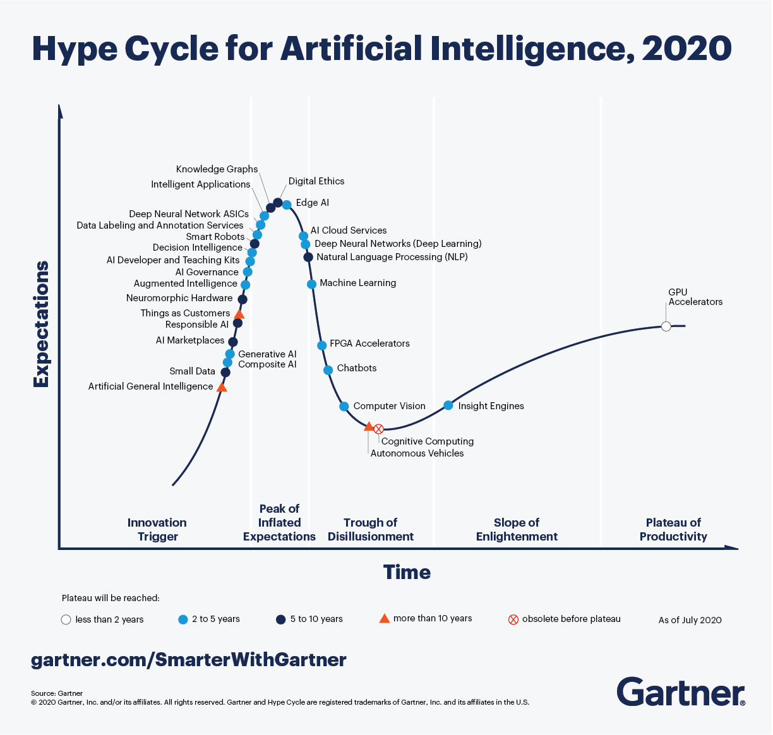

Looking at the Hype Cycle for artificial intelligence, focusing on the **blue** dots in the cycle, those are topics that are of interest in the next two to five years. An understanding of various innovation triggers in the space of artificial intelligence will help elevate conversation and make you stand out in the eyes of the interviewer. The answer is never to simply answer the question, but add an additional layer of context that will stick.

This blog will not tell you exactly how to answer questions when asked. It will explain what an instace of the best-in-class answes would sound like. We will try to use as many visual aids and examples to answer so that you can apply it in multiple scenarios and interviews.

# Structure of the blog

A lot of thought was put in as to what would make most sense in terms of structure when putting forth 100 AI interview questions and answers. For the first 50 questions, we will go over 5 questions each for 10 topics followed by 50 scenario-based questions. In the first section, we will try and cover as many current and future proof topics that we have seen being asked in some of the best analytics companies.

# **Part A: Topic-Based Questions**

Before we deep-dive into the questions below, let’s understand more about artificial intelligence and where it falls in the spectrum. In the recent past, Data Science has taken off in the space of technology, even being crowned as the Sexiest Job of the 21st Century. Let’s understand where Data Science belongs in the space of Artificial Intelligence.

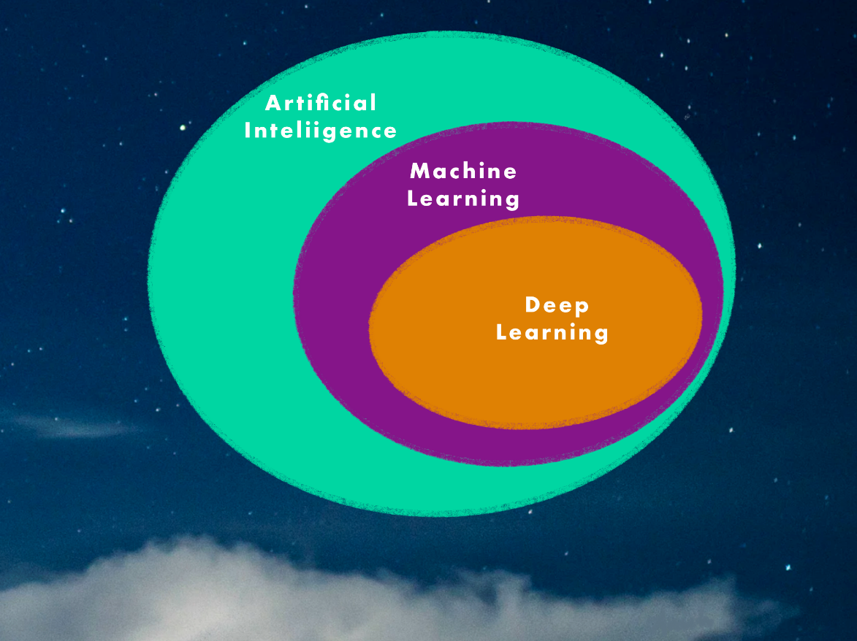

Figure 1: Data Science is a subset of Artificial intelligence

* **Deep Learning**: Subset of machine learning that leverages neural networks to train itself to perform layered tasks such as speech and image recognition
* **Machine Learning**: Subest of Artificial Intelligence which enables algorithms to learn without being explicitly programmed
* **Artificial Intelligence**: Programs with the ability to learn and reason like human beings

When explaining questions to an interviewer, remember, they are smarter than they look. No one knows everything about any topic. Especially in a subject like Artificial Intelligence, where new things are coming up at an exponential rate. When answering questions, be humbe and truthful. If you know the answer to the question, answer confidently. If you are unsure, be vocal about your thought process and the way you are thinking – take inspiration from the examples below and explain the answer to the interviewer through your experiences from projects and learnings. Alright, we have had enough fun building up to this moment, let’s dive right into the questions!

# 1 AutoML

## Q. What is Auto ML and how does it work?

A.

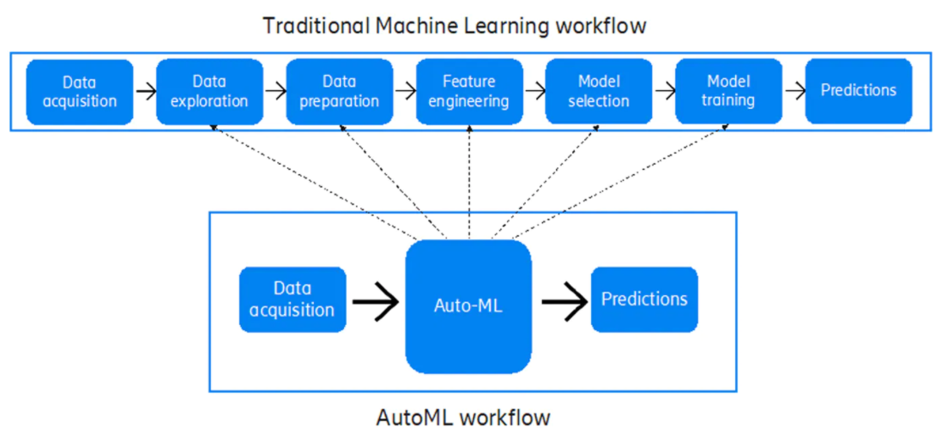

## Q. What are some ways to implement AutoML?

A [10 Popular AutoML Tools Machine Learning Developers Can Use (analyticsindiamag.com)](https://analyticsindiamag.com/10-popular-automl-tools-developers-can-use/)  
[AutoML: 7 Tools to Get You Started with Data Science Automation - victorzhou.com](https://victorzhou.com/posts/tools-for-auto-ml/)  
[11 Most Amazing AutoML Tools To Automate The Machine Learning (techgrabyte.com)](https://techgrabyte.com/11-automl-tools-automate-machine-learning/)

## Q. What is transfer learning and how does it compare to a neural architecture approach?

A. [Google's AutoML: Cutting Through the Hype · fast.ai](https://www.fast.ai/2018/07/23/auto-ml-3/)

## Q. What is GitHub’s copilot? Is it an implementation of AutoML – explain!

A. [GitHub And OpenAI Jointly Launch A New AI Tool, Copilot, Your AI pair programmer | MarkTechPost](https://www.marktechpost.com/2021/06/30/github-and-openai-jointly-launch-a-new-ai-tool-copilot-your-ai-pair-programmer/)  
[Is GitHub Copilot a blessing, or a curse? · fast.ai](https://www.fast.ai/2021/07/19/copilot/)

## Q. How does AutoML work?

A. [How does AutoML works?. “AutoML is not complete Data science… | by jeetendra gangele | Medium](https://medium.com/@gangele397/how-does-automl-works-b0f9e45fbb24)  
[How does Automated machine learning (AutoML) work? (eduonix.com)](https://blog.eduonix.com/artificial-intelligence/brief-introduction-automl/)  
[How does AutoML work? | MLJAR Automated Machine Learning](https://mljar.com/blog/how-does-automl-work/)  
[AutoML Tables Beginner’s guide  |  Google Cloud](https://cloud.google.com/automl-tables/docs/beginners-guide)

# 2 MLOps

## Q. What is MLOps and how does it work?

A.

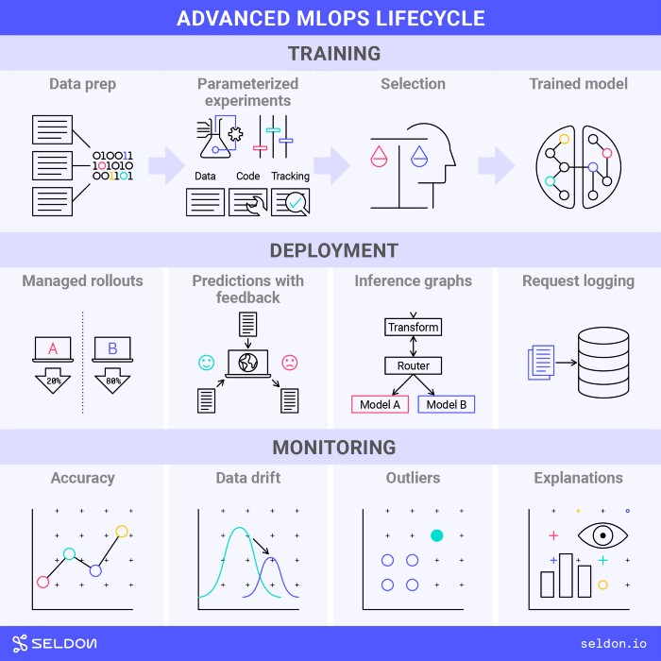

Figure 2: The end to end MLOps Lifecycle  
(Image by seldon.ai under the [CC BY-SA 4.0](https://creativecommons.org/licenses/by-sa/4.0/))

Q. What are some of the ways to push a ai/ml model to production? Explain the tech stack.

## Q. Explain how the MLOps lifecycle can be applied

A. [Applying the MLOps Lifecycle. Understand MLOps needs and how they… | by Ryan Dawson | Towards Data Science](https://towardsdatascience.com/applying-the-mlops-lifecycle-3b60033b7cbf)  
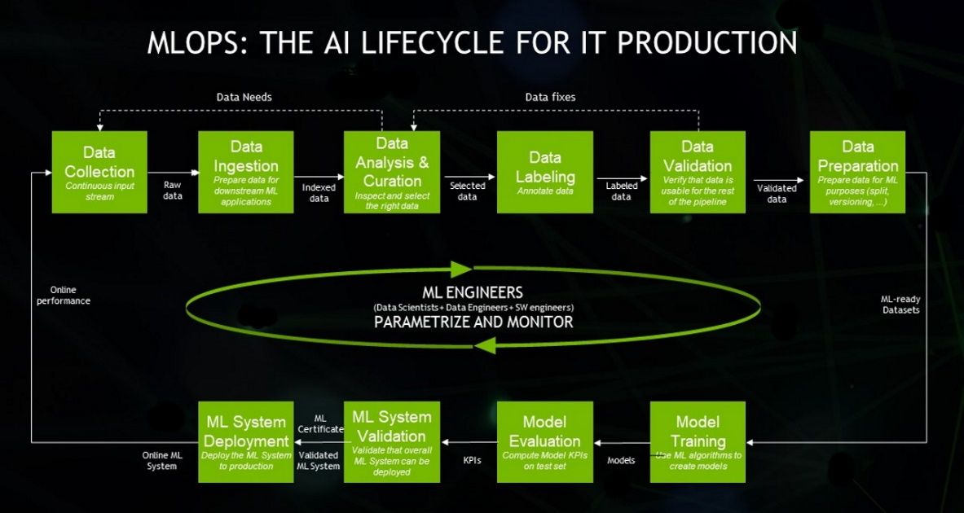

## Q. What is the difference between MLOps and DevOps?

A. [Applying the MLOps Lifecycle. Understand MLOps needs and how they… | by Ryan Dawson | Towards Data Science](https://towardsdatascience.com/applying-the-mlops-lifecycle-3b60033b7cbf)  
[MLOps vs DevOps. This article goes through the… | by Marco Susilo | Towards Data Science](https://towardsdatascience.com/mlops-vs-devops-5c9a4d5a60ba)  
[MLOps vs DevOps. What’s the difference? | by Demetrios Brinkmann | MLOps.community | Jun, 2021 | Medium](https://medium.com/mlops-community/mlops-vs-devops-whats-the-difference-60678e628756)  
[What Is The Difference Between DevOps And MLOps? (valohai.com)](https://valohai.com/blog/difference-between-devops-and-mlops/)

## Q. What are the components of MLOps?

A.

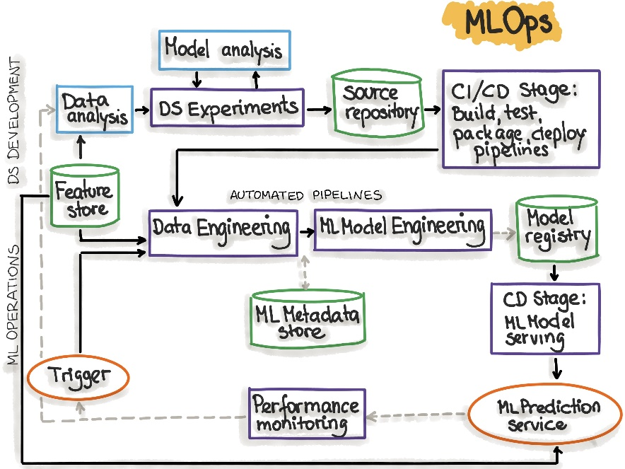

# 3 AI Cloud Service

## Q. What is an API? How do we deploy our own API to productionalize a ML Model?

A. [Deploying Machine Learning Model In Production (analyticsvidhya.com)](https://www.analyticsvidhya.com/blog/2017/09/machine-learning-models-as-apis-using-flask/)

## Q. What are the popular Cloud Services that support AI implementations? Explain!

A. FLASK and REST API   
[Comparing ML as a Service (MLaaS): Amazon AWS, IBM Watson, MS Azure | AltexSoft](https://www.altexsoft.com/blog/datascience/comparing-machine-learning-as-a-service-amazon-microsoft-azure-google-cloud-ai-ibm-watson/)   
[Data Science in the Cloud. Azure vs AWS vs GCP | by Ilai Bavati | Towards Data Science](https://towardsdatascience.com/data-science-in-the-cloud-239b795a5792)   
[Why ML Capabilities Of GCP Is Way Ahead Of AWS & Azure (analyticsindiamag.com)](https://analyticsindiamag.com/why-ml-capabilities-of-gcp-is-way-ahead-of-aws-azure/)   
[AWS vs Azure vs Google Cloud: What's the best cloud platform for enterprise? | Computerworld](https://www.computerworld.com/article/3429365/aws-vs-azure-vs-google-whats-the-best-cloud-platform-for-enterprise.html)   
[Comparing Google Cloud Platform, AWS and Azure | by Georgian | Georgian Impact Blog | Medium](https://medium.com/georgian-impact-blog/comparing-google-cloud-platform-aws-and-azure-d4a52a3adbd2)

## Q. What Cloud Service would you prefer? Why?

A. GCP

## Q. What are some scenarios where AI Cloud Service could be used to increase ROI?

A. [Explore AWS AI and machine learning services (amazon.com)](https://aws.amazon.com/machine-learning/)

## Q. What are the benefits of Machine Learning on the cloud?

A. [The Benefits of Doing Machine Learning and Analytics in the Cloud | The TIBCO Blog](https://www.tibco.com/blog/2019/12/09/the-benefits-of-doing-machine-learning-and-analytics-in-the-cloud/)   
[4 Key Benefits of Machine Learning in Cloud: Everything You Need to Know | upGrad blog](https://www.upgrad.com/blog/key-benefits-of-machine-learning/)   
[What are the Benefits of Machine Learning in the Cloud? - Cloud Academy](https://cloudacademy.com/blog/what-are-the-benefits-of-machine-learning-in-the-cloud/)

# 4 NLP: Natural Language Processing

## Q. What is NLP? Explain some use-cases of NLP?

A. [What is Natural Language Processing? | IBM](https://www.ibm.com/cloud/learn/natural-language-processing)   
[AI - Natural Language Processing - Tutorialspoint](https://www.tutorialspoint.com/artificial_intelligence/artificial_intelligence_natural_language_processing.htm)

## Q. What are chatbots? What are the various implementations of chatbots used?

A.

## Q. What are the main issues faced by companies when implementing chatbots?

A.

## Q. Explain some NLP use-cases.

A. [Cloud Natural Language  |  Google Cloud](https://cloud.google.com/natural-language)

## Q. How does Transfer Learning aid in building better and faster NLP models? What are the top three most popular implementations of pretrained language models?

A. [10 Leading Language Models For NLP In 2021 (topbots.com)](https://www.topbots.com/leading-nlp-language-models-2020/)

# 5 AI Governance & Scalable AI

## Q. Now that large companies are leveraging AI to make decisions that affect human beings everyday, it is important to critique the algorithms implemented. On that note, what is AI governance?

A. [The shape of AI governance to come - KPMG Global (home.kpmg)](https://home.kpmg/xx/en/home/insights/2020/12/the-shape-of-ai-governance-to-come.html)   
[perspectives-on-issues-in-ai-governance.pdf](https://ai.google/static/documents/perspectives-on-issues-in-ai-governance.pdf)

## Q. What are the components of AI Governance?

A. [AI Governance – What are the KPIs? And who is accountable? (2021.ai)](https://2021.ai/ai-governance-kpi/)   
[AI Governance Market Size, Share and Global Market Forecast to 2026 | MarketsandMarkets](https://www.marketsandmarkets.com/Market-Reports/ai-governance-market-176187291.html)

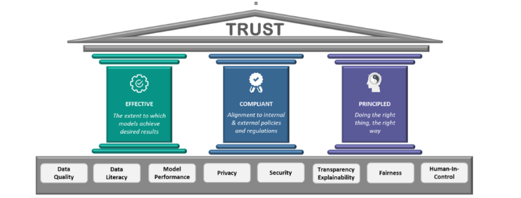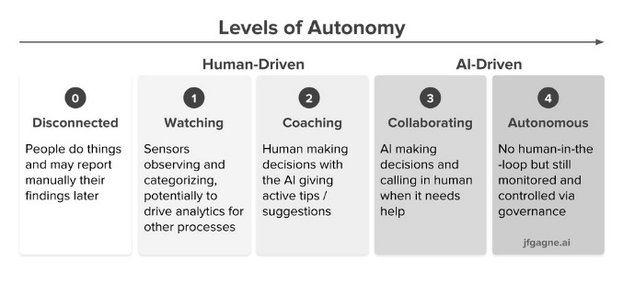

## Q. Good AI exists. Looking at the top companies in the world, we know that a robust framework exists where AI can scale. How do the best compnies in the world build Scalable AI?

A. [How leading companies scale AI. Five key principles to build an AI… | by Wouter Huygen | Towards Data Science](https://towardsdatascience.com/how-leading-companies-scale-ai-4626189faed2)   
[2021_019_001_735330.pdf (cmu.edu)](https://resources.sei.cmu.edu/asset_files/WhitePaper/2021_019_001_735330.pdf)

## Q. What are the difficultes when it comes to scaling implementations of AI?

A. [Scaling AI: 5 Reasons Why It's Difficult | Towards Data Science](https://towardsdatascience.com/scaling-ai-5-reasons-why-its-difficult-6ea77b9f7d48)   
[Scaling AI: How to Make It Work for Your Company | Accenture](https://www.accenture.com/us-en/blogs/intelligent-functions/scaling-ai-how-to-make-it-work-for-your-company)

## Q. State out the Enterprise AI Journey.

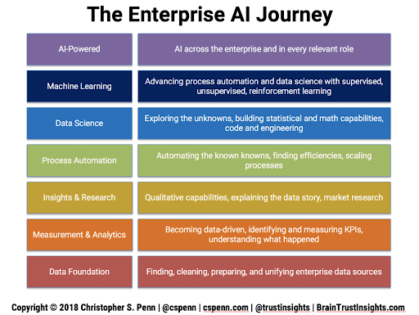

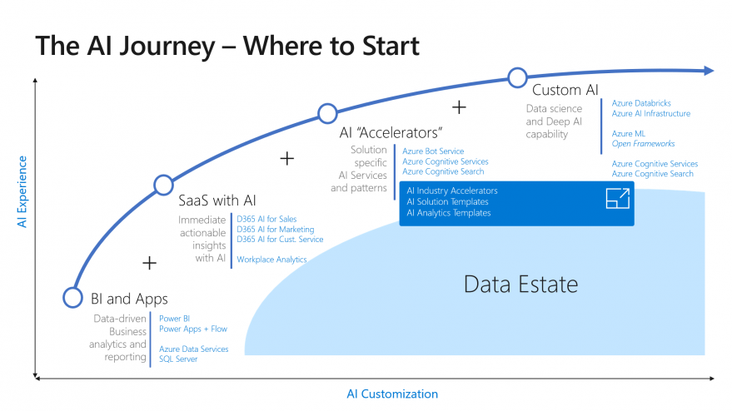

# 6 XAI / Explainable AI

## Q. What are some of the common problems faced by companies when it comes to interpreting AI / ML?

A.

## Q. Explain the concept of XAI and how it can be used in real world implementations?

A. [What is Explainable AI (XAI)?. An introduction to building trust in… | by Nicklas Ankarstad | Towards Data Science](https://towardsdatascience.com/what-is-explainable-ai-xai-afc56938d513)

## Q. If we were to consider AI/ML Models as black boxes that give us the desired output, what are some of the ways to help being trust back to the models being leveraged?

A. [Explainable AI — All you need to know. The what, how, why of explainable AI | by Lawtomated | Medium](https://lawtomated.medium.com/explainable-ai-all-you-need-to-know-the-what-how-why-of-explainable-ai-dcf2287a9f6c)

## Q. Explain some examples of tools and technologies that can help implement interpretable machine learning or XAI.

A. [Explainable AI (XAI) — A guide to 7 Packages in Python to Explain Your Models | by Prateek Bhatnagar | Towards Data Science](https://towardsdatascience.com/explainable-ai-xai-a-guide-to-7-packages-in-python-to-explain-your-models-932967f0634b)

## Q. All of the conversations about XAI seem to be problems of the future. If you were to design a ai / ml model for a business now and productionalize a model, what are some of the considerations you would have as a lead of the project?

A. [Explainable Artificial Intelligence (XAI): Will it be “The Next Big Thing” in AI ? | Medium | Medium](https://medium.com/@arunvaish9/explainable-artificial-intelligence-xai-will-it-be-the-next-big-thing-in-ai-eb240062a822)

# 7 Ethical AI / Federated Learning

## Q. With a world being driven more towards a privacy-focus mentality, what are some of the recommended approaches companies / teams can take to ?

A.

## Q. A common statement is “With the onset of the Digital Era”. In the coming years, as AI startes to take over more and more components of human life, the statement is going to transition to “With the onset of the AI era”. Is Ethical AI a real concern or just hype? What are the ramifications?

A.

## Q. How can Ethical AI be implemented at an enterprise level? What are its implications for Enterprise AI use-cases and Governance?

A.[Ethical AI: its implications for Enterprise AI Use-cases and Governance | by Debmalya Biswas | Towards Data Science](https://towardsdatascience.com/ethical-ai-its-implications-for-enterprise-ai-use-cases-and-governance-81602078f5db)

## Q. With privacy focus coming to the forefront, a lot of attention has been brought on data collected. A new branch of data collection and processing for ai / ml is federated learning. Explain further.

A. [Federated Learning | Towards Data Science](https://towardsdatascience.com/understanding-federated-learning-99bc86a0d026)

## Q. Explain how a model can be monitored after it is moved to production. Break down the approach.

A. [MLOps: Model Monitoring 101 | Towards Data Science](https://towardsdatascience.com/mlops-model-monitoring-101-46de6a578e03)

# 8 Cyber Security AI

## Q. Cybersercurity is the need of the hour. What is a good way to classify all security-related tasks using the PPDR framework?

A.

## Q. How can machine learning be used within the space of Cyber Security. Broadly explain the various elements of Cyber Security.

A. [Machine Learning for Cybersecurity 101 | by Alex Polyakov | Towards Data Science](https://towardsdatascience.com/machine-learning-for-cybersecurity-101-7822b802790b)   
[How Machine Learning will Transform Cybersecurity - BoTree Technologies](https://www.botreetechnologies.com/blog/machine-learning-in-cybersecurity/)

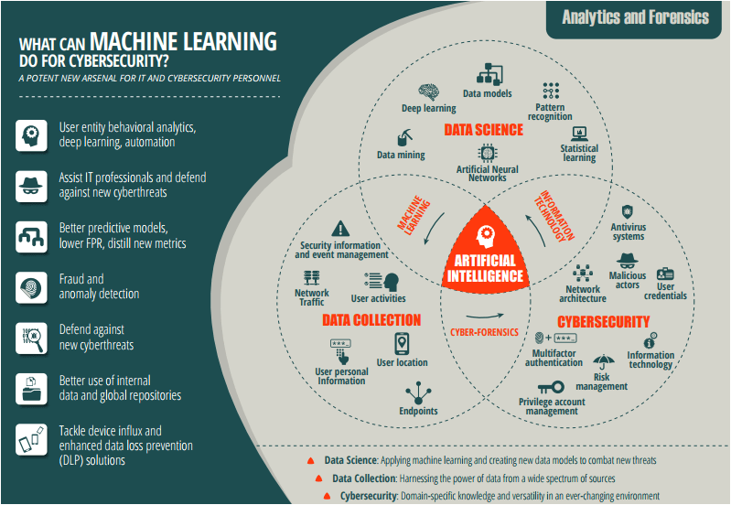

## Q. Mention ten use-cases as to how AI / ML can be used within Cyber Security use-cases.

A. [Machine Learning for Cybersecurity 101 | by Alex Polyakov | Towards Data Science](https://towardsdatascience.com/machine-learning-for-cybersecurity-101-7822b802790b)

## Q. Explain the flow of Cyber Security attacks and how AI / ML models can hel plug the gaps.

A. [Can Machine Learning Help Cybersecurity Systems? | Stout](https://www.stout.com/en/insights/article/can-machine-learning-help-cybersecurity-systems)   
[Artificial Intelligence vs. Machine Learning in Cybersecurity | Varonis](https://www.varonis.com/blog/ai-vs-ml-in-cybersecurity/)

## Q. How can Cyber Security be implemented across a PoC Team or at an enterprise-level with the help of AI / ML?

A. [Eliminating the complexity in cybersecurity with AI - Wipro](https://www.wipro.com/cybersecurity/eliminating-the-complexity-in-cybersecurity-with-artificial-intelligence/)   
[How Machine Learning will Transform Cybersecurity - BoTree Technologies](https://www.botreetechnologies.com/blog/machine-learning-in-cybersecurity/)   
[Can Machine Learning Help Cybersecurity Systems? | Stout](https://www.stout.com/en/insights/article/can-machine-learning-help-cybersecurity-systems)

# 9 RPA: Robotic Process Automation

## Q. What is Robotic Process Automation? Explain in brief with a few examples.

A. [Differences Between AI And RPA - When To Use Both | UiPath](https://www.uipath.com/blog/automation/ai-rpa-differences-when-to-use-them-together)   
[6 Smart RPA Adoption Challenges And Solutions | Market Insights™ - Everest Group (everestgrp.com)](https://www.everestgrp.com/2019-04-6-smart-rpa-adoption-challenges-and-solutions-market-insights-49802.html/)

## Q. What is the difference between AI and RPA?

A. [AI & RPA: What’s the Difference | NICE](https://www.nice.com/rpa/rpa-guide/rpa-ai-and-rpa-whats-the-difference-and-which-is-best-for-your-organization/)   
[The Real Difference between RPA and AI (chetu.com)](https://www.chetu.com/blogs/artificial-intelligence/is-rpa-part-of-ai.php)   
[RPA Vs. AI Vs. Machine Learning: A Comparison (crowdreason.com)](https://www.crowdreason.com/blog/rpa-vs-ai)

## Q. Explain the landscape of how RPA and AI can be used in tandem to increase revenue at an enterprise-level? Discuss a few use cases.

A. [AI & RPA - New Level of Automation | UiPath](https://www.uipath.com/automation/ai-and-rpa)   
[RPA & AI: Different Approaches To Problem Solving | Market Insights™ - Everest Group (everestgrp.com)](https://www.everestgrp.com/2018-01-rpa-ai-different-approaches-problem-solving-market-insights-43514.html/)   
[AI RPA - PS3G: Where Business and Technology meet](https://www.ps3g.com/solutions/ai-rpa/)

## Q. What are the phases of RPA at an Enterprise Level?

[(27) The convergence of RPA and AI can boost Business Process Automation | LinkedIn](https://www.linkedin.com/pulse/convergence-rpa-ai-can-boost-business-process-antonio-grasso/)

# 10 GANs: Generative Adversarial Networks

## Q. What are GANs?

A. [Understanding Generative Adversarial Networks (GANs) | by Joseph Rocca | Towards Data Science](https://towardsdatascience.com/understanding-generative-adversarial-networks-gans-cd6e4651a29)   
[A Gentle Introduction to Generative Adversarial Networks (GANs) (machinelearningmastery.com)](https://machinelearningmastery.com/what-are-generative-adversarial-networks-gans/)   
[Background: What is a Generative Model? (google.com)](https://developers.google.com/machine-learning/gan)

## Q. Provide an overall system view of GANs.

A. [Overview of GAN Structure  |  Generative Adversarial Networks (google.com)](https://developers.google.com/machine-learning/gan/gan_structure)

## Q. Explain some uses-cases on the variations of GANs.

A. [GAN Variations  |  Generative Adversarial Networks  |  Google Developers](https://developers.google.com/machine-learning/gan/applications)

## Q. Name some popular tools used for GANs.

A. [Top 10 Tools For Generative Adversarial Networks (GANs) (analyticsindiamag.com)](https://analyticsindiamag.com/top-10-tools-for-generative-adversarial-networks/)

# **Part-B: Scenario-Based Questions**

## 1Q. How can NLP be leveraged to tackle Fake News and Cyber Bullying?

A.

## Q. How would you build a governance model for AI in Healthcare. Give examples.

A. [AI Governance on Scalable AI - Google Search](https://www.google.com/imgres?imgurl=https%3A%2F%2Fwww.researchgate.net%2Fprofile%2FSandeep-Reddy-5%2Fpublication%2F337012288%2Ffigure%2Ffig1%2FAS%3A821590203850759%401572893777628%2FOutline-of-the-Governance-Model-for-Artificial-Intelligence-AI-in-Health-Care.png&imgrefurl=https%3A%2F%2Fwww.researchgate.net%2Ffigure%2FOutline-of-the-Governance-Model-for-Artificial-Intelligence-AI-in-Health-Care_fig1_337012288&tbnid=frLGozmuIC-gkM&vet=10CAMQxiAoAGoXChMI4Miyq9mQ8gIVAAAAAB0AAAAAEAs..i&docid=VCDsSUs5zTg_aM&w=850&h=350&itg=1&q=AI%20Governance%20on%20Scalable%20AI&ved=0CAMQxiAoAGoXChMI4Miyq9mQ8gIVAAAAAB0AAAAAEAs)

## Q. Gartner’s report says that 87% of ML Models do not make it to production. What are some of the gaps in the real world when it comes to productionalizing ML Models?

A.

## Q. A lot of Data Science is being done in Jupyter Notebook. What are some of the ways to productionalize a Jupyter Notebook?

A.

## 5Q. Name some common test frameworks that can be used in AI / ML models?

A.

## Q. Data Science is said to be primarily a combination of Math, Business and Technology. With automation of various systems in various fields, what does the future of Data Science look like?

A.

## Q. If you were to pick out top 10 best and worst performing products from across multiple warehouses across India, what would the approach be?

A.

## Q. Data Science is experimental in nature. Does logging play a part in Data Science? If so, please explain how.

A.

## Q. What is the difference between a client-serice and an in-house model in Data Science? What are some of the benefits and drawbacks of both?

A.

## 10Q. How you would design scalable architecture to accommodate varying data needs of an organization?

A.

## Q. What is streaming data? How are architectures designed to handle real-time data?

A.

## Q. Apple recently came up with a host of measures to advocate for privacy. How can machine learning scale at an organizational level keeping in mind privacy?

A.

## Q. What is FaaS? What is the imapact of FaaS in the Data Science industry?

A.

## Q. Exploratory Data Analysis (EDA) is an activity that has traditionally taken a lot of time. Is there any way to streamline and speed up EDA?

A.

## 15Q. Let’s take a general use-case of an an internet product that is run using ads. Name some of the key metrics that can be used to measure performance?

A.

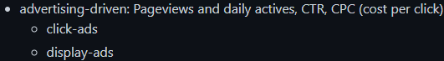

## Q. Let’s say that we are running ads on Facebook and Instagram to advertise our product. What are some of the ways to assess if engagement has been per expectations for the last month / quarter?

A.



## Q. Let’s say that we are Netflix and you are given a budget. How would you determine which Original Series we should put our money on?

A. 

## Q. Let’s say are serving a Fortune 500 company and we have the option of unlimited data. Is more data always better?

A.

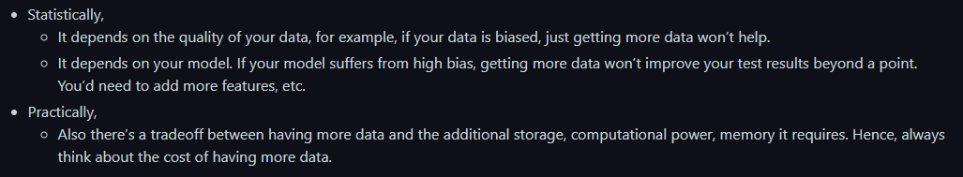

## Q. Let’s say you have a dataset with a million rows and 200+ columns. How can we determine what the most important features in the model are?

A.

## 20Q. Why do a lot of Kaggle Competition winners use Ensemble Learning? What is the main idea behind it?

A.

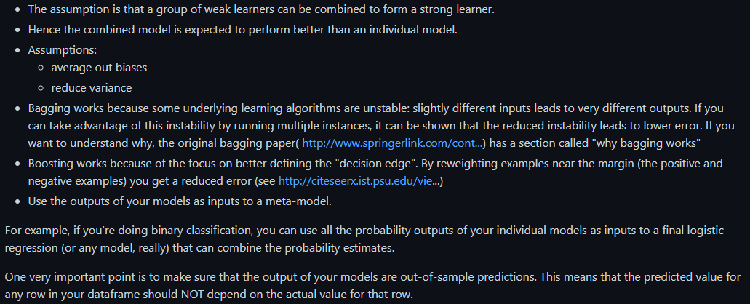

## Q. Let’s say that we are Uber. How can you use just the GPS data from the car to determine the quality fo the driver?

A.

## Q. Developers and product managers have hundreds of ideas on a daily basis. For the ideas that are selected to be tested, what is an efficient way to test these hypothesis in the real world?

A. [7 A/B Testing Questions and Answers in Data Science Interviews | by Emma Ding | Towards Data Science](https://towardsdatascience.com/7-a-b-testing-questions-and-answers-in-data-science-interviews-eee6428a8b63)

## Q. A lot of Data Science projects start our as PoCs. List out what are the things to keep in mind while building a PoC.

A.

## Q. What is a MVP? In a field as experimental as Data Science where experimentation is a part of the daily job description, what are some of the ways to maintain client confidence?

A.

## 25Q. How to build out a Data Science product from scratch?

A.

## Q. Let’s say you join a new team and are given data with no context. What would be your approach to prepare for analysis?

A.

## Q. You are given a classification problem on a fairly complix dataset. From your previous experience, you guesstimate that it will take ~3 months to processs the entire data with business context. How can you maintain client confidence intermittently?

A.

## Q. A popular algorithm used for classification is Naïve Bayes. Why is it considered “Naïve”?

A.

## Q. Let’s say you are given a large dataset of all customers of a telecom company with over 2 million rows and 2000 columns. You have to build a classification model to decide if a customer is likely to churn or not next month. You are given a laptop with limited RAM and no access to cloud resources. What are some of the ways you can go about this?

A.

## 30Q. You are very lucky and have got the opportunity to work for an interesting project that is deep in Data Science. The project deals with 5 VP-level stakeholders, all located across various timezones. You realize that every single person has different ambitions and expectations from this high-level project. What are some of the ways you could tackle such a situation?

A.

## Q. Let’s say you are dealing with customer churn data and you made a classification model with an accuracy of 97%! Why is this a bad measure? Explain your thought process.

A. 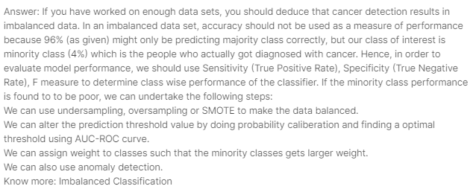

## Q. Projects in the past that used waterfall models used to give a lot of importance to documentation. However, projects that use Agile methodology do not give much importance to documentation. Do you agree with this assupmtion from the perspective of Data Science?

A.

## Q. Let’s say you are working on a large dataset and you have figured out that the data is biased. Now what?

A.

### Q. Let’s say that you have to upgrde the hardware for your team to be able to train complex ai / ml model. What are some of the ways you can go about this exercise in an economical manner?

A.

## 35Q. Let’s say that everyday more and more Burger King restaurants are opening across the globe. We also notice that everyday, more and more babies are being born. Does this mean that the increase in the number of Burger King restaurants is leading to more number of babies being born?

A.

## Q

# 1 Real World AI

A

# 2 Mainstream Computer Vision

A

# 3 Federated Learning

A

# 4 Enterprise-Grade AI Solutions

A

# 5 Future of AI

A